|  |  |  |
| --- | --- | --- |
|  | GOVERNMENT OF KARNATAKA | Form No: |
| Department of Technical Education | Revision: |
| Shree Vidyadhiraj Polytechnic, Kumta (370) -581362 |  |
| E-Mail: -svpkumta@gmail.com | Date: |

**Capstone project**

**Capstone project Execution Document**

**Capstone project Name:** Employee Database Management System

**Capstone project Members:**

* Deepti
* Deeksha
* Sounjna
* Nishmita

**Testing and validation**

Testing and validation of an Employee Database Management System is crucial to ensure that the system functions as intended, provides a seamless user experience, and meets the requirements and expectations of employees. Here are some key aspects to consider when testing and validating an Employee Database Management System.

**Functional Testing:** This testing focuses on verifying that each feature and functionality of the system works correctly. It involves testing different scenarios such as an adding the employee details, updating employee details, login in the system with credentials etc.

**Performance Testing:** Performance testing measures the system's responsiveness, scalability, and stability under different loads and stress levels. It involves testing aspects like page load times, response times of the website, and the ability to handle concurrent users. Performance testing helps identify and address any bottlenecks or performance issues that could impact the user experience.

**Compatibility Testing:** Compatibility testing ensures that system works seamlessly across various devices, operating systems, and web browsers. It involves testing the system on different platforms, including desktops and laptops to ensure consistent functionality and appearance.

* Cross Browser Testing of the system in Google Chrome Browser.

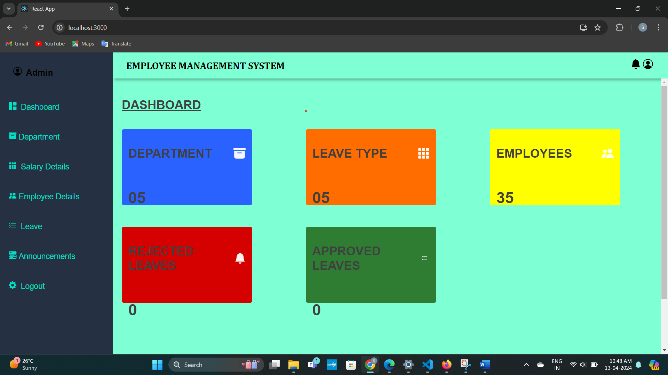

* Cross Browser Testing of the system in FireFox Browser

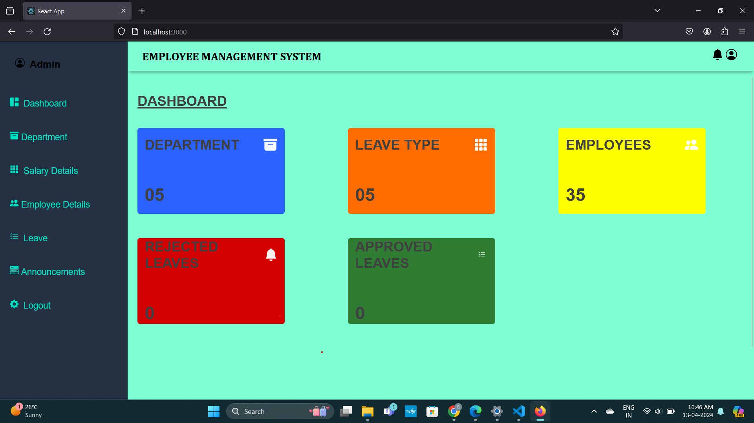

* Cross Browser Testing of the system in Microsoft edge Browser

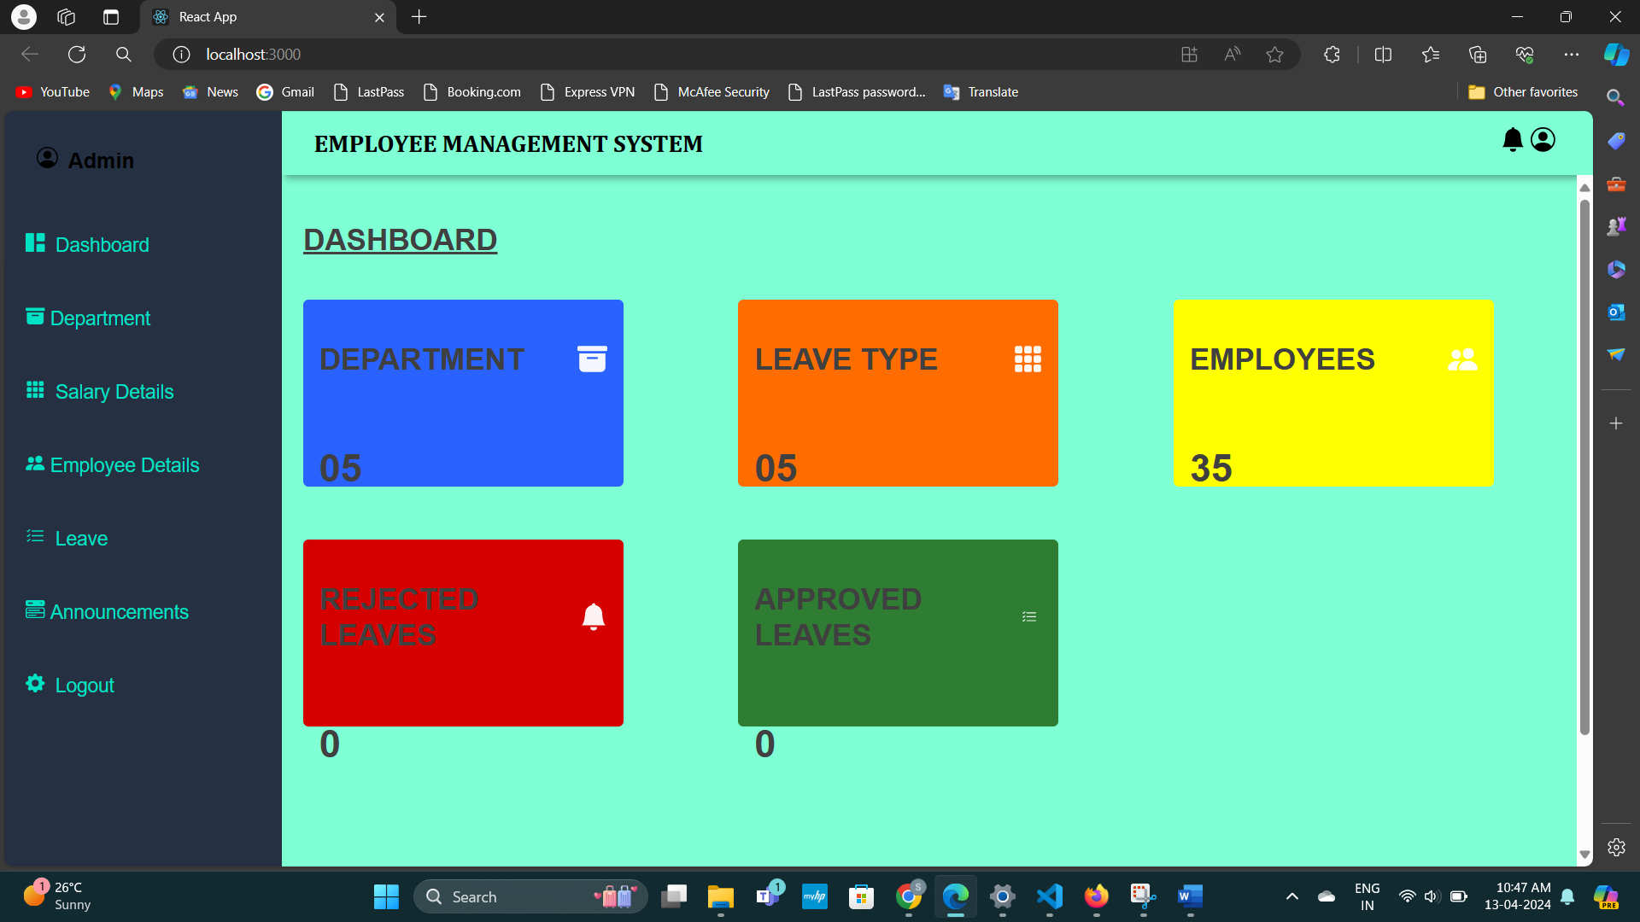

**Usability testing:** This involves testing the website's user interface and overall user experience to ensure that it is user-friendly, and easy to navigate.

**Security Testing:** Security testing focuses on identifying vulnerabilities and weaknesses in the system that could potentially lead to data breaches or unauthorized access.

**Testing API Used in the System**

* Fetch all the employee details from database to display it to the User (GET API)

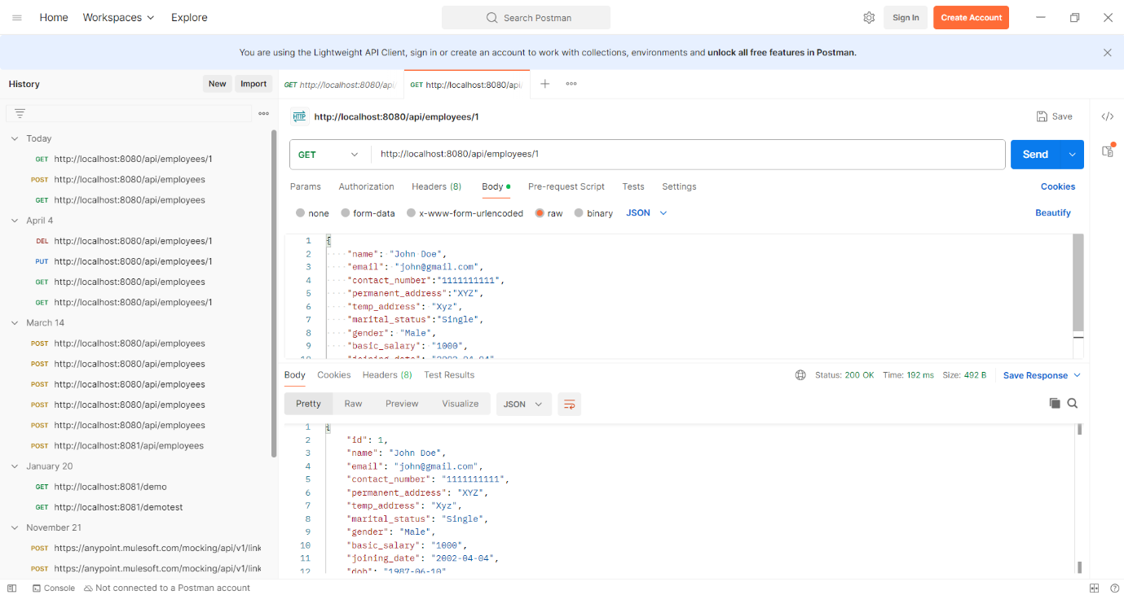

* To delete specific employee from the database (Delete API)

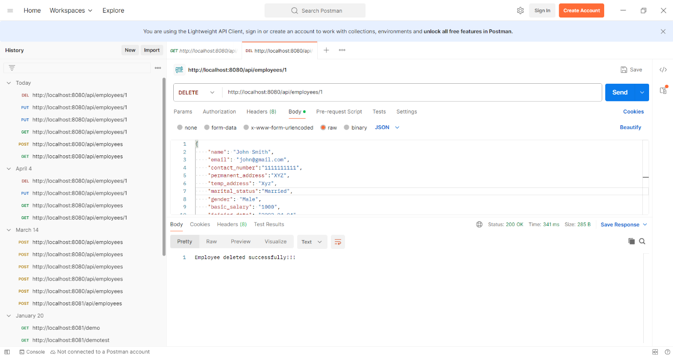

* To add a new employee detail to the database (POST API)

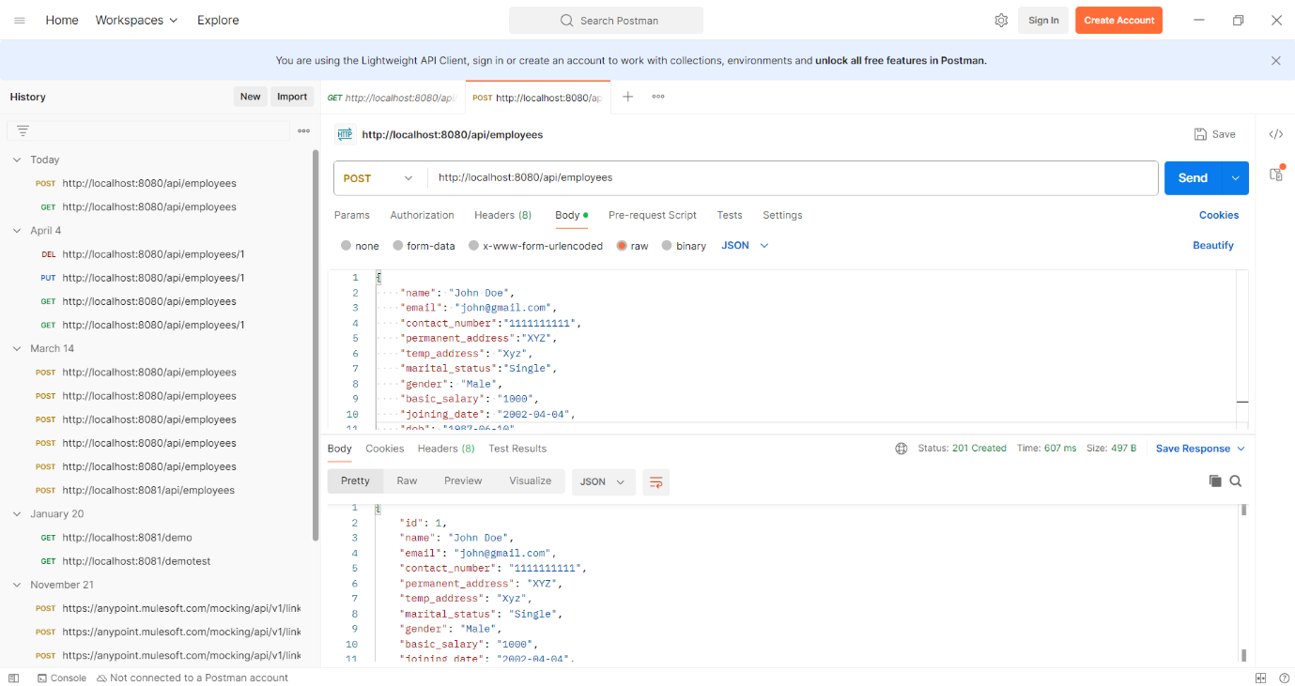

* TO update employee details in the database (POST API)

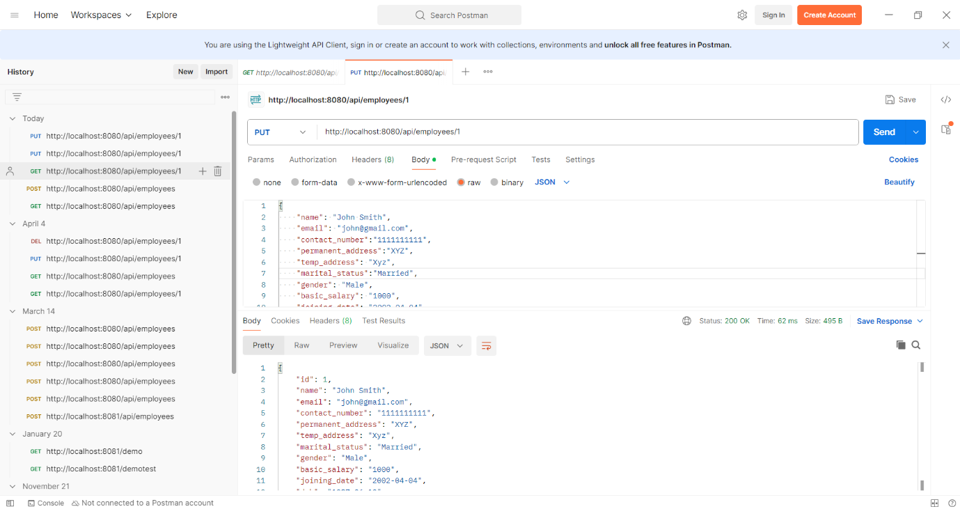

**Result**

The results of an employee database management system can vary depending on several factors such as the platform's features, user experience, marketing strategies, competition, and overall market conditions. However, a successful employee database management system can yield several positive outcomes:  
  
**Increased Efficiency in Employee Management:** The system facilitates easy management of employee records, update existing employee information, and remove records when employees leave the college. This streamlined process saves time and ensures data accuracy.

**Improved Leave Management:** Employees can submit leave requests through the system, which are automatically routed to the appropriate admin for approval. This reduces paperwork and manual processing time. The system tracks employees' leave balances, providing accurate information on available vacation days, sick leave, and other types of leave. This helps prevent scheduling conflicts and ensures fair allocation of time off.

**Data Security and Compliance:** Employee data is stored securely in the database, with access restricted to authorized personnel only. The system maintains detailed audit trails of all changes made to employee records, providing transparency and accountability in data management practices.

**Competitive Advantage for the College:** A well-managed employee database system enhances the college's reputation as an employer of choice. By efficiently managing faculty and staff records, the system supports academic and administrative functions, contributing to the college's overall success and competitiveness.

**Enhanced Salary Management:** The system automates salary calculations based on predefined rules and employee data, reducing the risk of errors and ensuring timely and accurate payments. Employee data from the database can be seamlessly integrated with payroll systems, simplifying the payroll process and reducing administrative overhead.

**Inference**

The inference of an employee database management system refers to drawing conclusions or making judgments based on the available information and observations about the system. Here are some possible inferences that can be drawn about an employee database management system :  
  
**Increased Convenience in Employee Management**: An employee database management system provides convenience by allowing admin to manage employee records from any location with internet access. They can add, update, or delete employee information remotely, saving time and effort compared to manual record-keeping methods.

**Greater Accessibility to Employee Information**: An employee database management system provides access to comprehensive employee information. This accessibility enables college administrators to quickly retrieve employee data, such as contact details, salary structure and leave balances, as needed.  
  
**Enhanced Employee Experience:** An employee database management system focuses on enhancing the employee experience. User-friendly interfaces and self-service portals empower employees to manage their personal information and submit leave requests with ease, leading to greater satisfaction and engagement.

**Improved Operational Efficiency:** An employee database management system streamlines admin processes and improves operational efficiency for the college. Automated workflows for tasks such as leave management, and payroll processing reduce manual errors and administrative burdens. Real-time access to employee data facilitates quicker decision-making and resource allocation, contributing to overall efficiency.

Signature of the Student

Date :

Signature of the Cohort Owner